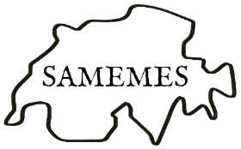

Tolerance and Dissent
Swiss Association of Medieval and Early Modern English Studies
Ninth Biennial Conference
University of Fribourg
Wed-Fri, 24-26 June 2026

Programme

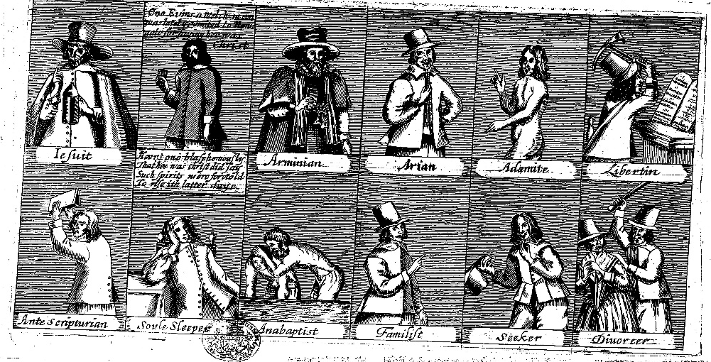

Organisers:
Kilian Schindler, Elisabeth Dutton, Honor Jackson
(University of Fribourg)

samemes2026@unifr.ch
www.samemes2026.com

 | Wednesday 24 June
10:00 - 10:30 | Registration open, coffee
10:30 - 11:00 | Opening remarks
11:00 - 12:00 | Keynote lecture  Alexandra Walsham (University of Cambridge)  Records of Prejudice?  Finding Tolerance in Early Modern Archives of Religious Persecution
12:00 - 13:30 | Lunch by own arrangements
13:30 - 15:00 | Political Resistance and the Limits of Tolerance  Izzi Strevens,  ‘“If that I do speak the word, how dare ye once say nay?”: Execution and Dissent in Thomas Preston’s Cambyses’  Catherine Jenkinson,  ‘Descriptions of Dissent: the Antwerp Citadel and London’  Laura-Sophie Stolzenberg,  ‘“Ein rechter Christ kann Fairfax that Nicht gut heissen noch preisen’’ (“A true Christian cannot approve of or praise Fairfax’s deed”): Instances of (in)tolerance in Anna Ovena Hoyers’ (1584–1655) poetic response to the regicide of Charles I (1649)’ | Dissent on the Shakespearean Stage  Ina Habermann,  ‘Roads to redemption in Shakespeare’s A Midsummer Night’s Dream and Shakespeare and Fletcher’s The Two Noble Kinsmen’  Pascale Aebischer,  ‘Free speech and martyrdom in Shakespeare and Peele’s Titus Andronicus’  Gemma Kate Allred,  ‘That’s not my Hamlet, his [BLANK] is too [BLANK]’
15:00 - 15:30 | Coffee break
15:30 - 17:00 | Genre, Publication, and Literary Afterlives  Nadine Weiss,  ‘Shakespeare’s Religious Sonnet: A Critical Stress Test’  Emma Depledge,  ‘A Genre Shaped by Toleration and Dissent: The Publication of Mock Heroic Poetry’  Regula Hohl-Trillini,  ‘“Must nit alle Schawspiel sähen”: Swiss reservations about early modern English theatre’ | Adaptation and Dissent  Emily Smith,  ‘Representing Dissent: Mediating the Medieval and Early Modern’  Benjamin Broadribb,  ‘The Henriad Echoes of This is England’  Simon Heller,  ‘Medievalism and Dissent: Vietnam War Revisionism through Beowulf’
17:30 - 18:30 | Welcome reception  Centre le Phénix (Rue des Alpes 7)
18:30 - 19:30 | Performance: Anne Ridler, The Trial of Thomas Cranmer  Centre le Phénix (Rue des Alpes 7)
 | Thursday 25 June
09:15 - 10:15 | Keynote lecture  Adrienne Williams Boyarin (University of Victoria)  Literary Tolerance?  English and Hebrew Poetry in Late Thirteenth-Century Norwich
10:15 - 10:45 | Coffee break
10:45 - 12:15 | Articulating Dissent  Abbie Fray,  ‘“Sounds more like the diabolical cries of peacocks”: Queer Sensory Rhetoric as Political Communication in the 1381 Peasants’ Revolt.’  Georgia Fulton,  ‘Early Modern Lucian: Dialogue as Dissent’  Douglas Clark,  ‘Suicide in Early Modern English Pastoral Drama’ | Dissenting Women  Sonya Cronin,  ‘“Aen Strang Monopollie”: Gender, Stuart Libel and Performing Dissent in the Lady Margaret Wemyss Songbook Miscellany’  Honor Jackson,  ‘Tolerated Dissent and Its Dissolution: Female Parliamentarianism in Aphra Behn’s The Roundheads’  Simone Camponovo,  ‘“Down goeth all the Pots and Dishes”: Stirring Culinary Dissent in Margaret Cavendish’s Matrimonial Trouble’
12:15 - 13:45 | Lunch by own arrangements
13:45 - 15:15 | Domestic Dissent  Kevin Laam,  ‘Marriage and the Politics of Dissent in Lucy Hutchinson’s Memoirs’  Courtney Beale,  ‘Domestic Monstrosity and Dissidence in Book V of Spenser’s The Faerie Queene’  Anne-Claire Michoux,  ‘Displays of Sensibility: Undomesticated Women of the Theatre, 1750-1830’ | Tolerance and Dissent in Milton’s Paradise Lost  Damien Elsig,  ‘Self-Shaping Dissent in Medea, Lady Macbeth, and Milton’s Satan’  Nino Töndüry,  ‘Repressive Tolerance in Eden: Adamic Dissent and the Making of Binary Sex in Paradise Lost’  Antoinina Bevan Zlatar,  ‘John Milton’s Son of God, Diabolical Dissent, and the Limits of Heterodoxy’
15:15 - 15:45 | Coffee break
15:45 - 16:45 | Keynote lecture  Sharon Achinstein (Johns Hopkins University)  ‘Two opinions doe not well on the same Boulster’:  Milton, Divorce, and Civil War
19:00 - 21:00 | Conference dinner  (Pizzeria Ristorante Molino, Rue de Lausanne 93)
 | Friday 26 June
09:30 - 10:30 | Online keynote lecture  Suzanne Conklin Akbari (Institute for Advanced Study, Princeton, NJ)  The Virtuous Pagan in the ‘New World’:  Indigenous Encounters with Christian Missionaries on Lenape Lands |  | Friday 26 June
10:30 - 11:00 | Coffee break
11:00 - 12:30 | Tolerance across Borders  Angana Moitra,  ‘“The matter of Religion to be tolerated”: Tolerance and Dissent in the Elizabethan Marriage Match’  Elias Marcel,  ‘Transcultural Effects of the Muslim “Moral Rearmament”’  Günay Heydarli,  ‘Negotiating the Other: Visual Culture, Confessional Anxiety, and Diplomatic Tolerance in the Anglo-Safavid Encounters, 1600–1700’ | Transgressive Identities  Lucie Kaempfer,  ‘Emotional Dissent and the Limits of Tolerance in Partonope of Blois’  Olivia Golby-Kirk,  ‘Performing Nonconformity: Dissenting Masculinity in Seventeenth-Century English Ballads’
12:30 - 12:45 | Closing remarks
12:45 - 14:00 | Lunch by own arrangements
14:00 - 16:00 | SAMEMES AGM

