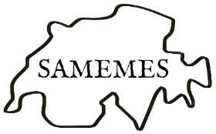

Tolerance and Dissent
Swiss Association of Medieval and Early Modern English Studies
Ninth Biennial Conference
University of Fribourg
Wed-Fri, 24-26 June 2026
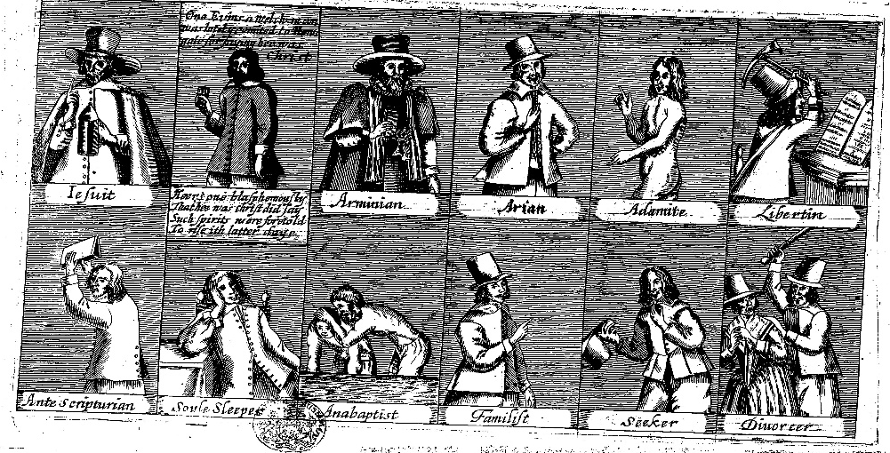
Organisers:
Kilian Schindler, Elisabeth Dutton, Honor Jackson
(University of Fribourg)

Keynote Speakers:
Sharon Achinstein (Johns Hopkins University)
Suzanne Conklin Akbari (Princeton University)
Alexandra Walsham (University of Cambridge)
Adrienne Williams Boyarin (University of Victoria)

Pre-liberal societies responded to the challenge of managing dissent in a wide variety of ways, from violent persecution over systematic discrimination to pragmatic compromises and measures of containment. However, dissent was also a creative force, which shaped literature, religion, politics, cultural identity, and communities from below – and sometimes demanded fundamental civic liberties and tolerance. Although tolerance is commonly considered a product of the Enlightenment, revisionist scholarship in recent decades has amply demonstrated a rich and varied history of tolerance that stretches far back into the early modern period and the middle ages and is by no means an exclusively Western phenomenon.
This conference aims to explore the interplay of tolerance and dissent from the perspective of medieval and early modern English studies by considering the ways in which literature, religious and political polemics, ephemeral print, and other forms of writing and performance responded to practices and discourses of tolerance and dissent. We understand tolerance and dissent in their broadest senses and invite contributions that examine any aspect of the whole spectrum of attitudes and practices, from revolutionary uprisings and violent persecution on the one hand to utopian models of dissent and constitutional guarantees of liberty and equality on the other. While ‘tolerance’ is often defined as self-imposed restraint or legal forbearance towards persons, convictions, or practices of which one disapproves, it was also often deeply intertwined with repressive impulses. Tolerance was by no means always inspired by a principled commitment to liberty, but was often temporary, granted grudgingly for pragmatic reasons, and accompanied by feelings of profound ambivalence. Dissent likewise took many forms – from clandestine alienation and subtle subversion to performative non-conformity and open rebellion – and was as much about shaping alternative visions of the world as it was about rejecting prevailing norms.
While much research on medieval and early modern tolerance has traditionally been concerned with religious conflict, this conference aims to cast a wider net that also includes the linguistic and literary representation of sexual dissidence, ethnic difference, intercultural contact, the regulation of the book trade and press censorship, or the subversion of linguistic and literary norms, to name just a few. We further invite contributions that move beyond intellectual history and an exclusively top-down focus on the policies of tolerance pursued by political authorities and other institutions, in order to consider how individuals respond to policies of tolerance – or the lack thereof – and how local communities and popular forms of writing and performance are implicated in regimes of tolerance and intolerance, respectively. We invite submissions for 20-minute papers or pre-formed panels on all aspects of the conference theme, which may include, but are not limited to:

- Challenges to orthodoxy: religious reform, mysticism, heresy, dissent, and non-conformity
- Persecution and martyrdom
- Dissimulation and conformity
- Censorship and the book trade
- Literary and linguistic strategies of dissent
- Performing tolerance, conformity, or dissent
- Public and private spheres of dissent
- Education and tolerance
- Tolerance as a personal virtue (e.g. Stoicist tolerantia)
- Sexual dissidence
- Dissent and gender (e.g. strategies and conditions of female dissent)
- Medieval and early modern discourses of race
- Rebellion, revolution and resistance
- Tyranny and its representation
- Tolerance and dissent on foreign shores: colonialism, travel writing, and the new world
- Tolerance and dissent in utopia/dystopia
- Repressive tolerance and containment of subversion

For 20-minute conference papers or panel suggestions, please send a 250-word abstract (per paper) and a short bio (max 100 words) to samemes2026@unifr.ch by the newly extended deadline of 13th February 2026. Select papers presented at this conference will be published in the open-access and peer-reviewed Swiss Papers in English Language and Literature (SPELL) in 2027. More information on the conference, travel recommendations, travel grants, etc. is available under: http://www.samemes2026.com.

The book prize deadline has now passed and is not extended: Early-career members of SAMEMES are invited to submit their first single-authored book, written in English and published between 1 January 2024 and 31 December 2025, for the SAMEMES Book Prize (CHF 1’000) before 15 January 2026. Candidates must be paid-up members of SAMEMES by the CFP deadline for the biennial conference and be present at the conference at which the prize is announced. The monograph must be submitted in the form of two hard copies to the SAMEMES President before the end of 2025:

Prof. Emma Depledge (emma.depledge@unine.ch)
Institut de langue et littérature anglaises
Espace Tilo-Frey 1
2000 Neuchâtel

More information on the book prize is available under: https://samemes.net/conference/book-prize/

